What there is the Earth of Israel? - if all hollows,
and mountains of Israel to straighten, it is-All the
World.
(Torah)
The Person, nothing made for construction of the
Temple, is guilty of its destruction.
(Rabbi from Liubavichy)
-What for that road if it does not conduct to the
Temple?
-if the road which you have constructed, blue as
color of a flag if on this road all Nations of the world
have presented you everything that have made
-if you, at construction of this road, from a stone
taken from the ground, has constructed the Temple,
- Then this Road, Yes, conducts to the Temple!

Construction of a ship-canal in Israel.

(Commercial idea)
When Supreme bequeathed Erez - Israel to Jews, It has named their selected people, having assigned that the huge responsibility on this People. It has ordered to learn a Torah and to observe traditions. But to study-does not mean continuously to read and cram by heart, so to apply according to studied.
The Creator could not, having named People the Selected works to code it on eternal, stupidly repeated day by day, from year to year, from century to century, - citing of texts with what they sacred were, criticizing his and to jeers of all nations of the world.
Having granted the ground of Israel to Jews, It knew, that, not looking at full absence in it what or minerals, People of Israel will guess the riddle incorporated by It, and at an o'clock when the doubt will confuse all nations of the world, will prove the especial once and for all.
We are obliged to make this ground prospering and - to the present rich. The rich country? Rich people, and on the contrary. It would not be desirable to be engaged in empty rhetoric, but the fact remains the fact: for prosperity of the country stable sources of incomes should be created.
The country cannot plan from year to year the budget focused on the donations of world Jewry and for simplification of burden of an economic situation periodically, but with a shameful constancy, to come back to a theme of increase of taxes, or turnings of social programs.
Has burst an economic crisis. The markets have failed. And clever Jewish heads can offer nothing such that will cardinally change an economic situation.
The present project was born not Thoughtlessly. The author has come to it after the long analysis of materials from set of sources. Studying history of the people of Israel, getting acquainted with statements of the ancient philosophers resulted in a Torah and other sacred Books, getting acquainted with weight of great projects, including history of a birth of Suez, Corinthian, Panama channels, the decision of the riddle put in the Sacred Earth Supreme came nearer. The last, turning point to start work on the project was the thought stated by Teodor Herzel in the novel "the Earth Promised" where he has declared that there will come time when in the Jewish state even through desert the ships will go instead of camels!
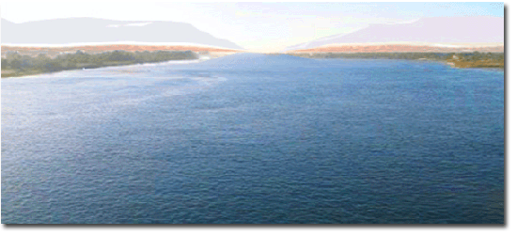
Leaning against the received knowledge, a wide experience of the seafarer, an economic education, I have started the project. The result of the first predesigns amazes imagination! As a result of project realization "Buildings of the navigable sea channel", the state Israel will receive in treasury Unprecedented hitherto incomes. The people of Israel will have an opportunity to work and apply the knowledge on huge space of possibilities. In the country in times the budget will increase and possibilities for weight of social programs will open. Appear unprecedented before a way of the decision of the Palestine-Israeli opposition.
And after all right now, at the moment of the world crisis, at the moment of general confusion, there has come time of reconsideration of our position in the world, an exit from an economic crisis and long-term stagnation.
One of economy organic laws consists that creation in the country of conditions favorable for investments; by all means conducts to those investments will not keep it waiting. And at the moment of the world economic crisis when holders huge Finances search for such, global projects, as offered here, demanding multi-billion injections, and guaranteeing return to investors of the enclosed means with profit, simply find. And to miss this, given Supreme chance, would be an inexcusable error. The organic law sane beings, - to study on good examples and not to miss the chance, and, acquiring knowledge, it is obligatory to apply them in the ability to live, to use the best efforts, to follow to the treasured purpose? To perfection, helping the people and the country with their aspiration to lifting, well-being, the world and independence!

The historical inquiry.

Thought on digging the channel through Isthmus of Suez, has arisen in an extreme antiquity.
Antique historians, in particular Strabon and Pliny the Senior, inform that the channel connecting the right sleeve of Nile with Red sea, Pharaohs of an epoch of the Average kingdom tried to build still Phivani.
The first authentic historical evidence of connection of the Mediterranean and Red seas the channel concerns times of board of Pharaoh Neho II (the end VII-The beginning of VI century BC).
Expansion and channel improvement was made under the order of the Persian tsar Darija I who have won Egypt, and subsequently- Ptolemej Filadelf (first half III century BC) . However in 767 the system of the channels connecting Nile with Red Sea, has been destroyed by order of the Arabian Caliph al-Mansur. Since then any works on restoration of this ancient trading way it was not conducted.
Preconditions for realization of technically difficult and labor-consuming project have appeared only during new time. Building of Suez Canal is connected with Ferdinand's name de Lessep, the French vice-consul in Alexandria in 1832-1833 and the consul in Cairo in 1833- 1837.
Having conceived this grandiose enterprise, Lessep has come into friendly contacts with deputy Egypt Mohammed Ali. However Lessep and did not manage to be convinced of necessity of building of the channel Ali, its successor deputy Abbas I. Nevertheless, eventually, the persistence of Lessepa has been rewarded: on November, 30th, 1854 it has received from hands of replaced Abbasa-1 - deputy Saida the desired decree which has given to it concession on building of Suez canal. Thus Lessep has been named in the text of the decree by words “Our friend”.
The French contractors of Linnan de Belfon and Muzhel have made the contract design of a line of Suez canal. Its bookmark has taken place on April, 25th, 1859 this day Lessep with councilors of the company and has arrived into place where the city of Port Said named so in honor deputy Said has soon grown. After the short speech devoted to significant event, Lessep with own hand has spent the first furrow on a line designating a contour of the channel.
On a channel construction it has been simultaneously occupied from 40 to 60 thousand workers. Provide building by a labor of Lessep smog, only having achieved at deputy Said of the edition of the decree about compulsory mobilization of peasants. It was ordered to rural heads to drive on building of inhabitants of nearby villages. Because of intolerable working conditions on building of Suez canal, according to some information, was lost to 120 thousand Egyptians.
During the first period of excavations almost all became manually. The friable soil did not allow to carry a ground in wheelbarrows, and quite often it was necessary to lift a wheelbarrow and on hands to bear it to an unloading place. Difficulties were aggravated with that the district chosen for the channel, was crude and marshy.
Even the superficial trench dug on purpose to designate a channel of the future channel, in an hour was filled with water. Then workers were built in a chain of across constantly going deep channel, from one coast to another. That who was in the centre, water reached a belt. Having lifted a shovel a clod of the earth from a trench bottom, they transferred it along all chain. On the brink the earth put in linen bags. Having filled a bag, working clambered on a slope upwards and already there threw out the earth. Only at the building final stage steam-engines have been used. The huge volume of excavations has demanded perfection of digging technics. In particular, specially for building of Suez canal dredgers, conveyors, dredges, cargo launches with elevating devices have been created huge for those times……

In March, 1869 of water of Mediterranean sea Bitter lakes, and in half a year, have rushed on November, 15th in lying on a channel line, solemn opening of the channel has taken place.
………….. At 3 o'clock in the afternoon on November, 16th all invited have gathered on coast. Behind the triumphal arch decorated with flowers the kind on three magnificent pavilions, built on a sandy shallow opened. Average intended for guests of honor, at the left there was a blue pavilion for Christian divine services, on the right- Green-for the Muslim. After solemn speeches guard’s parade deputy Ismail has taken place, and the big fireworks in the evening have been arranged. The people exulted. Only the main hero of the festivities, Lessep, tore on itself hair with despair: just to it have brought the emergency telegrammed:”All was gone”- A steamship making trial pass on the channel, The ship has sat down on a bank……
……..В 8 hours of 15 minutes of morning on November, 17th through the channel the yacht of the French empress has moved ”Egel”. Behind it- Frigate of the British ambassador, and then already a chain of various courts. The waterway has been designated by red beacons. About 8 o'clock in the evening, near to Ismailia the caravan had to rise on an anchor: a steamship “Peluziy” sat down on a bank also has blocked a way to other ships. Then new complications began to arise: it has appeared that in several places the channel was nearly twice more small planned 8 m.
All night long there was a meeting. It has appeared that in deadly haste had not time to finish work on deepening of the basic channel of the channel, and instead of the provided 8 m of depth in many places it has appeared much less. It threatened pass of the ships with big depth. The majority of participants of meeting tended to postpone opening solemn ceremony. And during this critical moment only one Lesseps could keep cool. Under its insisting the strong-willed decision was accepted: to open the channel and to pass a part of the ships of small displacement.
Suez Canal connects Port Said on Mediterranean Sea and Suez on Red sea. Transportation of cargoes through the channel remains to one of the cheapest and safe ways of transportation of the goods between Europe and Asia. Opened for navigation in 1869 the channel long time was under control of Frenchmen and Englishmen.
On July, 26th, 1956 the president of Egypt -Gamal Abdel Naser declared its nationalization.

Economy

Economy - a science, in my opinion, concerning more to natural sciences, rather than to the exact sciences.
At the decision-making, based on the economic analysis and exact calculations, correct preparation business - the plan, as a rule, realization of projects passes smoothly, means are spent rationally, results are visible already at the first stages of its realization.
It is very important, if the considered Project, has no analogues, bears in itself considerable incomes, promotes attraction of a great number of investors and it is calculated on long time.
Today, at the height of the world economic crisis, the Project offered by me, not only answers everything above listed to requirements on presence of economic preconditions, but also provides global changes in state of Israel existence.
That the demonstrative base of the Civil-engineering design the Trance of the Israeli ship canal was weightier, to me it seems pertinent on this stage to acquaint all with the data about Suez Canal.

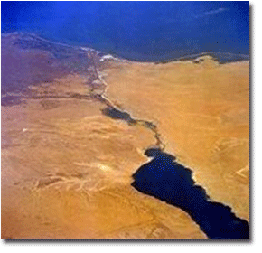
Suez Canal connects Port Said on Mediterranean Sea and Suez on Red sea. Transportation of cargoes through the channel remains to one of the cheapest and safe ways of transportation of the goods between Europe and Asia by the sea transport. Opened for navigation in 1869 the channel long time was under control of Frenchmen and Englishmen.
On July, 26th, 1956 the president of Egypt Gamal Abdel Naser declared its nationalization. Operation of this water corridor is one of the basic sources of currency receipts in the Egyptian treasury along with export of hydrocarbons, tourist sector and remittances of the Egyptians working in other countries.

Now through the channel annually pass more than 30 thousand courts under flags more than 100 countries of the world. In the sum they transport about 300 million tons of various cargoes. Through the channel passes 14 % of total amount of world trade, the most part of oil transportations from area of Persian Gulf to Europe and America.
In 2007-2008 financial year Suez Canal has achieved record incomes in 5 billion 113 million dollars that almost on 1 billion dollars exceeds indicators of previous years.
This historical inquiry is necessary for the review of a theme - of presence exciting us, or absence, reasons on ship canal building in Israel. At desire digression to history of Suez Canal is easy for finding today in the Internet. As a rule, the information on it is accompanied, become already norm, boastful “Pearls” Both the writing Egyptian press and echoing those mass-media of the different, interested countries. Any information on the channel is accompanied by references on”A revolution gain” And other delirium.
For example: the Magazine "Al-Ahram al-Iksisadi", has reminded that the channel makes an integral part of national consciousness of Egyptians, it is identified by them with all gains of revolutions.
And hardly someone undertook to approach to studying of history of Suez canal dazzling with malicious infringements of laws of economy and its operation critically. And after all inability of Egyptians correctly to concern to them, on the present national property, has allowed me to start development of a theme of building of a ship canal in Israel in 1999 year.
Today Egyptians refer to the Economic crisis which has led to reduction in February, 2009 of a gain of Egypt from sea transportations through Suez Canal almost on 25 % in comparison with similar month of last year as 23.03.2009 has reported "France Press" referring to representatives of administration of the channel - one of the major world Sea transport arteries.
According to the received information, in February the gain from operation of Suez Canal has decreased from 408 million dollars in February, 2008 to 302 million dollars in 2009 Number of the courts passing through the channel, has decreased for the same period with 1272 to 868.
The volume of cargo transportation through the channel also has decreased. In February this indicator has made 53 million tons in comparison with 73 million tons in similar month of last year.
To construct Suez Canal, initially, did not make special work since followed only connect among themselves three lakes and, using low district, to dig further - in the north to Mediterranean, and in the south to Red to the seas.
1.The basic engineering miscalculation: Already then and till now that fact is not provided that, passing on the marshland surrounding lakes, the channel will constantly grow, be filled with silt and to decrease on depth of the channel.
Received additional inflows of sea water, the lakes connected among themselves, day by day, during all time of operation, are diluted and fill with the suspensions a canal.
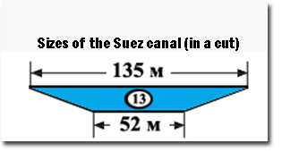
Instead of constructing drainage system, to strengthen coast, and to drain bogs, a worthless management of the channel, throughout 140 years spends huge means on not stopping deepening of a waterway of work.
At channel Administration the fund in which 25 % of all total receipts for financing of capital works and permanent jobs on channel deepening are brought is created.
However, despite allocated, not the small money resources, once deepened to 20 meter depths, depth of the channel again decreases. Today the channel management officially guarantees to seafarers depth of 13 meters that is maximum permissible for swimming of large-capacity fleet. Every year published by the International Sea Organization (IMO) notices inform on tens the ships, which have sat down on a bank, following Suez Canal.

2. For the reason connected with small dimensions of the channel, critical depth and constantly varying channel the Administration of Suez canal has established following restrictions:
- A pilotage across Suez canal, the following from port of Said, it is carried out daily by two caravans: The first caravan goes at 23 o'clock 00 minutes, the second - at 7 o'clock 00 minutes.
- Conducting across Suez Canal of the courts following from port of Suez, is carried out daily only by one caravan which 30 minutes go at 4 o'clock.
All vessels which were earlier passing on the channel, should arrive to Port Said for following in the first caravan not later than 21 hours 00 minutes, in the second - not later than 4 hours 45 minutes, to request the pilot and to legalize papers on vessel pass… Etc.

“During the last years incomes of Egyptians of pass of Suez canal by bulk-oil courts have decreased, as, in opinion “Experts”, trying to rescue image of the friendly country, the alternative pipeline transport constructed for swapping of oil and gas in parallel to Suez canal, and a sea route round cape of Kind Hope began to use rather a great popularity….” (Nonsense I do not make comments – Yuri G.)

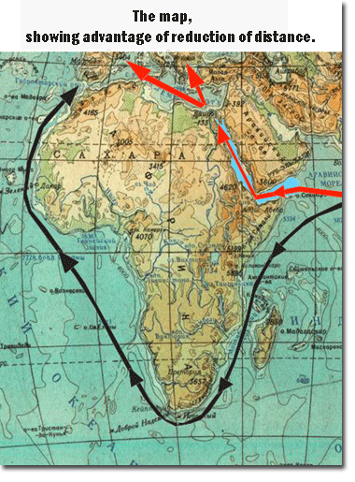
”Formation of currency reserves of Egypt always occurred mainly at the expense of a gain received from export of oil (3,7 billion dollars), incomes of operation of Suez canal (2 billion dollars), remittances of the Egyptians working abroad (3 billion dollars), and incomes of tourism (4,3 billion dollars). Reduction of currency reserves of the country is caused partly by decrease in profitable receipts from the given sources on the general background of delay of rates of development of economic…” (?-Yuri G.)

(“ The KUBAN STATE UNIVERSITY” Chair of anti-recessionary management, taxes and the taxation. The abstract ”Egypt in economic” Has executed by the student of 3 courses, of group 316 -Belikova A.A. –Russia-).

About the services given by the Egyptian experts in conducting of foreign courts, it is possible to write novels. Till now registration of formalities for channel pass is interfaced to inconceivable red tape, mass small requisitions in mix with vandalism of the personnel rising aboard of a vessel. Their quantity is always inexplicable is great: 10-20 persons.
Became norm of preparation of a vessel to pass through Suez canal when crew of the vessel, preparing to follow on the channel, welds electric welding on a deck all subjects, first of all from nonferrous metals which the so-called personnel can steal, and the senior officers of a vessel prepare a large quantity of cigarettes for a presents for the so-called experts which appetite for 140 years of work of the channel has not decreased at all.

Advantages of the Israeli project "Ship Canal Building".
The channel should connect Mediterranean (Ashkelon) and Red (Eilat) the seas, having passed through desert Negev.
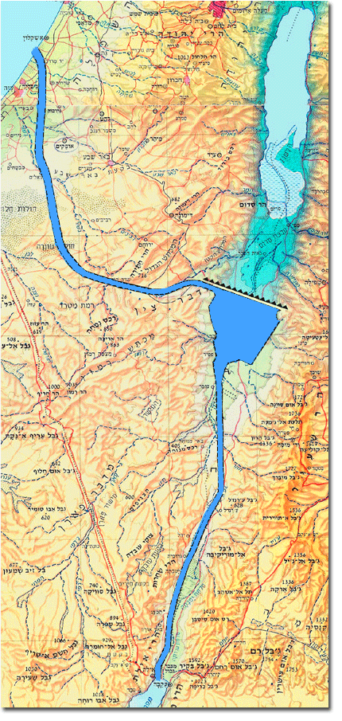
The Geographical position of Israel and, accordingly, its ship canal the same as also Suez it is located in an isthmus zone between Mediterranean and Red by seas that is a determinative of reduction of a way of the courts following from Asia to Europe and America on the shortest way, on 5-9 thousand miles reducing distance, rather than to float round Africa.
Long-term activity of Suez Canal, as though critically we did not concern its operation, has executed the primary goal: has involved in itself goods traffics of all Worlds. To us remains only, to construct the channel, considerably best on all technical and navigating indicators, rather than Suez. Unlike Suez Canal, the Israeli ship canal is laid in dry, frequently, to stony soil.
It has huge advantage in front of Suez canal since we avoid the huge expenses connected with clearing of the channel, laid in marshland. Dissecting the Negev’s height in its lowest place (600 m over Sea line), are equal from the north-northwest on the south-southeast, further, using a natural hollow of the Dead Sea, and, fenced off from penetration into the Dead Sea a dam, the channel turns along a hollow on the south-southwest, in a direction of Eilat-city.

Length of the channel about 252 km = 136 nav. miles
Width - 500 m;
Depth of a waterway -about 50 m.
A channel Estimated cost -about 350-600 billion dollars

Suez Canal was under construction per 1859-1869 picks and shovels.
Level of development of the modern industry allows to conduct building of the Israeli ship canal, undoubtedly, more modern techniques, quickly, with the account of requirements of 21st century and, with prospect on 22-nd.
If heads of building consider possible to conduct channel building simultaneously from 5-10 points in the shortest terms (3-5 years) it can be started in operation.

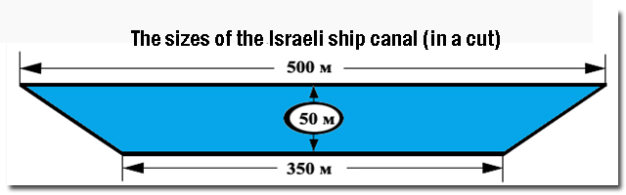
Creation of more modern conditions of navigation in the Israeli ship canal, in comparison with Suez.

Primary factor of successful operation of the Israeli channel is its size. Its throughput depends on the sizes of the channel, its width and depth of its waterway.
Calculation at building of similar hydraulic engineering constructions should provide that fact that their operation is planned for ever, and should consider development of world large-capacity fleet.
Unlike Egypt, we cannot admit that court deadweight (load-carrying capacity) of 300 thousand tons and more. Because of impossibility of pass by Suez Canal, they follow round cape of Kind hope (round Africa). Dimensions of our channel should provide unobstructed and safe pass of large-capacity fleet.
If the ships of all types can go on the Israeli channel at full speed, not strongly constrained in its width and the depth, it is the keystone to success.
The sizes of the Israeli ship canal offered by me will allow ships of any type, at the approach to the channel to follow without a stop, reducing speed only for a capture aboard the pilot and representatives of boundary and customs service.
The sizes of the Israeli sea ship canal allow ships not only to follow on the channel at full speed, but also in case of need to make overtaking, without fear of leaving from a waterway.

Table
of comparison of speed of pass
by the ships of Suez and Israeli ship canals

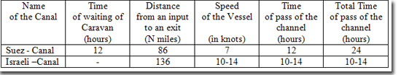
At pass by the Israeli channel economy of time at each vessel - 10-14 hour.

If to compare passableness of channels, preceding only from dimensions the Israeli variant of the channel completely will satisfy requirements of ship-owners. And consequently, it is easily possible to assume that already at the operation initial stage, the Israeli channel will allow to spend approximately 90 thousand units of fleet a year that corresponds to transportation of 4,5 billion tons of cargoes with a gain of 36 billion dollars.
Through the channel will pass 25 % of total amount of world trade, the greatest part of oil transportations from area of Persian Gulf to Europe and America.
But, it only a part of incomes which will be received by Israel from operation of the channel.
When through our channel will pass to 20-25 % of total amount of the goods of the world and the most part of oil transportations from area of Persian Gulf to Europe and America, it is necessary to understand that the certain percent of the cargoes necessary for the country, with little effort will remain here.
It is necessary to offer only the conditions favorable for investments, and foreign capitals will begin to flow in the country, as the river.
What is available in view of? Egypt did not have not enough 140 years to understand that the channel and territories adjoining to it can be used not only for transfer of cargoes, and for processing going to Europe and America of cargoes.
After all many of the cargoes, transported for addressees in delivery ports, there are processed in finished goods, being frequently the basic income filling budgets of these countries.
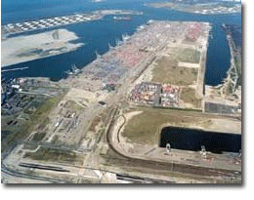
As example it is served by Rotterdam, Antwerp, and Amsterdam, Hamburg. So prevents to be engaged to our country in the same?
Many consignors and addressees of cargoes will be glad to reduce time of delivery of cargoes and instead of expenses to get profit on manufacture and finished goods realization a month earlier, than was earlier.
Favorable conditions for investments will necessarily promote inflow of capitals, considerable quantity opening businesses, connected with processing and manufacture of a huge spectrum of the goods, to occurrence of the navigable companies which will incur delivery of small parties of cargoes to concrete addresses, is direct in ports where there are consumers.

Special interests.

Despite the fact that Israel has outlets in all the oceans, its fleet in the port, located on the Mediterranean coast, unable to free navigation on the shortest route to the Indian and Pacific Oceans.
Without the ability to "frisk" and excessive openness to the Arab world, he does not pass the Suez Canal. It cannot respond to the economic interests and national security. Not to mention the fact that a precedent was one reason for a 6-day war, when Egypt nationalized the Suez Canal, just banned the passage of Israel Float.
If Israel is a channel with these dimensions, even submarines will be able to pass from the Mediterranean to the Indian Ocean, not being seen by satellites and other technical means of tracking and espionage from foreign countries.

Ecology.

Digging a canal removed a huge amount of soil, and in its place comes water.
By my conservative estimate, desert Negev will get about 6, 5 billion cubic meters of water.

Calculation
of the volume of soil excavated during the construction
of the channel bed and the volume of water filling the navigable channel.
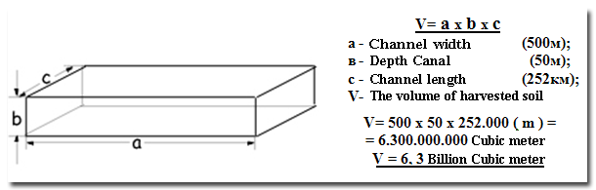

This amount of water can not affect the improvement of ecology once desolate and arid parts of the desert.
Vaporized, the water in the form of clouds, held by mountains, in significant quantities are condensed in the atmosphere, will continue to fall as precipitation, previously absent in the area.
Seeping through the earth strata, through sand, stone, clay, chalk and other components, the water will replenish underground reservoirs mineralized, filtered, almost fresh water.

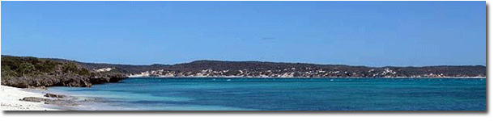
Vegetation along the canal will be capable of its root system to perceive the coastal moisture, which is typical for the coast all the oceans and seas. Man, however, may accelerate the planting of vegetation such an artificial way.
The presence of an abundance of sunlight in this area allows the use of a vast territory for the installation of solar power and gets cheap desalination of sea water in quantities sufficient to irrigate the desert.
Concerned for the replenishment of water from the Dead Sea, scientists are controlled spillway water channel near the dam. Built there station laboratory will do this in a scientifically sound mode.
If the discharge from the dam into the Dead Sea will be quite energy efficient, not difficult to construct a water turbine, which allows for this to generate electricity.
The movement of water in the channel because of the different heights of the Red and Mediterranean seas (Red Horizon above the Mediterranean at 9 m), is 1 knot (1.8 km / h) will be mixing of the water will the temperature difference and biological composition, which naturally attracts marine organisms, and fed them different species of fish. A huge attraction for the fish will appear with the advent of this new volume of water.
Of course, all these business ideas need to connect the academic experts. I would not want to desire to get a lot of billions of dollars of profit in any way reflected in the deterioration of the ecology of the region.
But populism in the evaluation of benefit - harm to the channel, may remove the very long term, if ever, a vital project.
The examination must be thorough and scientifically sound.
In the case of the project work of scientists - ecologists, hydrologists, ichthyology is for all time the existence of the navigable channel tightly linked to its exploitation.

Military-political aspect.

Without pretending to the title of a military expert, I reason is simple:
- We have very strong and efficient army in the Middle East,
- We have the most advanced design, aircraft and tanks,
- Our troops are very high motivation.
Enumerate the dignity of the Israeli war machine can be long and more professionally than I did it, an ordinary economist and captain of the commercial fleet (Deep Sea Captain).
But let's look at our stand from the side. Restricted area does not allow Israel to have an absolute guarantee of security in the event of a serious war. We must not forget that the students of military academies in many disciplines, not friendly countries, students from Palestine and Lebanon, learn and improve their military knowledge, learn from mistakes made, and quite possibly dream of the Blitzkrieg.
We won the Six day war, won the Yom Kippur War. We shelled out a bit during the intifada, a little, a little more - in most intifada. We conducted reconnaissance in force in Lebanon and showed that we can break up a hostile country for a few days. We have shown the strength and well-conducted operation "Molten Lead" in Gaza.
But every time we obviously felt like melting resources and the question arises in me, both in a kaleidoscope, the Government on budget cuts, including the army.
Perhaps such a military confrontation enough for a long time. Or maybe not.
Surely we have in the vaults of the "new Sharons" ...
But what if the enemy wills "Zhukov", for example, the new Hitler - Ahmadinejad? And they unite with the five well "packaged" by money countries and to do it in complete silence? Satellites and reconnaissance work well not only in Israel! What will our valiant air force, if in a few minutes will be mutilated runways of all "secret" airports?
How many missiles can shoot down unit "Patriot" in a minute, Ten, twenty, forty?
And if they both fly a hundred, but without stopping during the day? ...
I do not want to agree to the Apocalypse, I'm not typical. This is the inheritance of those who saw no way out.
I did say: "Out there. It is obvious. And based on the integrated use of the army and modern means of social simulation and state-building ".
It so happened that there Strip is one of the most densely populated areas in the world. Who not only denounces Israel for oppressing the "innocent civilians" in Gaza. Who is there not only muddies the people. We are constantly trying to determine which of the Palestinian terrorist organizations - less than a terrorist, to support her in the fight for the right to once again promote the people of the Palestinian Authority to fight the aggressor, Israel.

Of course, the Army can solve some problems in resolving the situation in the Palestinian Authority, but it seems to me, only one, real-world scenario.
In cooperation with the Americans (probably part of Australia, Japan, Germany and Canada), we must:
1. How can be quickly put in the Gaza governor-general.
2. Legalize in Gaza demilitarized zone.
-Interim Administration to issue a decree for the surrender of all weapons (including cold).
-allocate a special budget, based on intelligence data, for the generous

Proportional to encourage sit-arms and informants.
3. In all schools to appoint teachers, prepared from citizens participating in the program developed countries, Arab and Palestinian descent. Specialists, vetted for loyalty to the participating countries, committed to the modern human values.

4. In mosque imams to pick up, serving the peace towards religion.
5. Help to open factories and workshops, equipped with modern equipment, capable of producing a peaceful, competitive product, including cement and iron-processing is not big factories.
Following the measures taken, and began work on the construction of Israel's shipping channel, to recruit specialists and workers from Gaza and the entire Palestinian Authority in good conditions, wages, corresponding to the best European standards.
The vast majority of the Palestinian Authority, ultimately, evaluates the actions of Israel and the countries - participants, on in dignity.
When in the life of the people appear less dramatic change when the work will be a joy, and new social conditions and new opportunities - to the envy of many inhabitants of the Arab countries. When the establishment of autonomy deals with the device of a new institution of life. I do not think that the fathers of families receiving so many benefits to his day off, for the sake of diversity, will take up arms.
In the morning they go to work, which they have recently and could not even dream.

Problems of the Dead Sea.
(How to save the Dead Sea?)

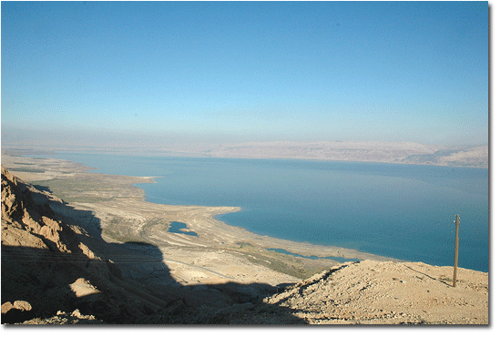
(Photo by Konstantin Guterman)

Dead Sea can imagine how - everything except a dead hard for him to submit. What is characteristic is the fact that it is sick. Human activities here were over half a century entails explicit consequences.
The sea recedes at a dangerous pace, about 1 meter per year. Even remembering where beach bar located adjacent to the Hotel 10 years ago, shows that the level receded, but the depth has decreased by 10 meters. This is determined visually.
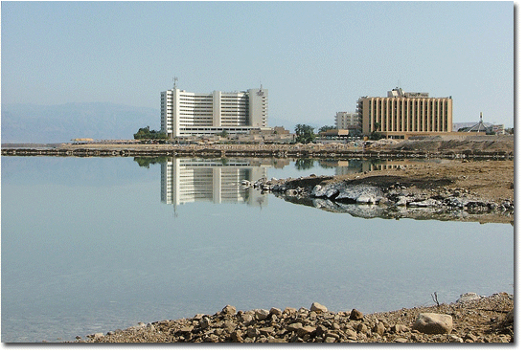
(Photo by Konstantin Guterman)
Scientists of Israel, together with the Jordanian investigators are trying to identify the different phenomena that influence the Dead Sea and its region.
The main problems facing the Dead Sea, due to increasing consumption of water in their homes, businesses and activities. But the main problem is the selection of water countries on whose territory the river runs. Jordan. As you know, the Jordan River Dead Sea helps to maintain your balance.
Complicated problem and for large industrial plants that are in the south of the Dead Sea. On both sides of the border, the Israeli company Dead Sea Works and the Jordanian Arab Potash extract rare and precious minerals.
In the cosmetics market as a small quantity of minerals mined in the Dead Sea.
The problems of the water shortage in Israel have always been, but today this shortfall is most acute.
Extraction of minerals in Jordan and in Israel, making a significant is contribution to the gross national product of both countries. Cease development at the Dead Sea is not easy.
The Resort and recreational resorts of Israel at the Dead Sea, famous throughout the world for its unique natural mineral products, well are at a dangerous point of existence. The Israeli team of scientists conducting research, as we know, is developing a variety of plans to save the Dead Sea. One of the plans, which have begun to talk more about 10 years ago, involves the construction of a canal between the Red and Dead seas.
Of course, the construction of the channel would be expensive, and, moreover, may entail a number of unknown effects that are associated with changes in the ecosystem. In the Dead Sea, the lowest point on earth, water gets through is specific flora and fauna, created in the process of mixing the waters of Lake Kinneret, which feed the Dead Sea, the small streams and seeps through the ground, rainwater.
And of course, this flora has nothing to do with that which arises from the simple spillway of seawater into the Dead Sea.
However, seem plausible that many, many years, the soil around the Dead Sea from - for all the above mentioned natural phenomena and human activities, more and more loses moisture, washed out and not filled.
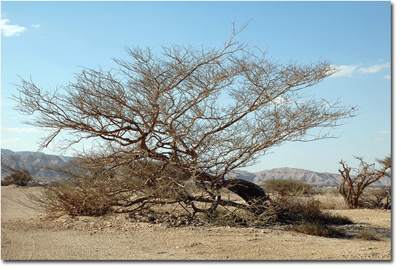
(Photo by Konstantin Guterman)

And in this connection I wish to recall that in implementing the project "Construction of the shipping channel in Israel" in the region will come about 6, 5 billion cubic meter water. This amount of water can not affect the improvement of ecology once desolate and arid parts of the desert Negev and the Dead Sea area. Vaporized, the water in the form of clouds, held by mountain range in significant quantities, condenses in the atmosphere, will continue to fall as
Precipitation, previously absent in the area.
Seeping through the earth strata, where there is sand, stone, clay, chalk and other components, the water will replenish underground reservoirs saline, fresh water. Vegetation along the canal will be capable of its root system to perceive the coastal moisture, which is typical for the coast all the oceans and seas. A person can accelerate greening of the region, by planting vegetation by artificial means.
Abundance of sunlight in this area allows the use of a vast territory for the installation of solar power and get cheap desalination of sea water in quantities sufficient to irrigate the desert. And Caring for replenishing water from the Dead Sea scholars are controlled spillway water channel near the dam.
Constructed there station laboratory will do this in evidence-based mode, through an artificially constructed body of water with desalinated water. If the volume of the reservoir spillway dam in the Dead Sea will be quite energy efficient, not difficult to construct the water turbine, which allows for this to generate electricity.
Of course, all these business ideas need to connect the academic experts. I would not want to desire to get a lot of billions in profits earned by Israel since the start of operation of the shipping channel, in some way affected the deterioration of the ecology of the region. But populism in the evaluation of benefit - harm to the channel, may remove the very long term, if ever, a vital project.

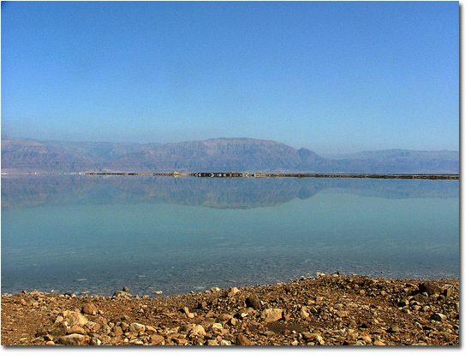
(Photo by Konstantin Guterman)

The examination must be thorough and scientifically sound. In the case of the project work of scientists - ecologists, hydrologists, ichthyology be for all time the existence of the navigable channel tightly linked to its exploitation.

Before drawing conclusions on the project, I have counted necessary to place on this page one more, very important information visually characterizing those many-sided options which are brought with itself by realization of the civil-engineering design of a ship canal in Israel.
New territory is not a violent way.

Even with the approximate calculation discharged from the construction of the channel, the volume of soil, one cannot but notice the possibility of its use (see calculations).

Calculation
of the volume of soil excavated above the water line.

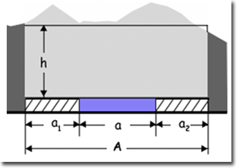
V(over) = A x h x L

V(over)- The amount of soil excavated above the water channel.
A = a1 + a2 + а
а1 - The width of the left shore of the channel
= 100 m;
а2 - The width of the right shore of channel=100 m;
а - channel width;
А - overall width of the channel with the coastal strip of the left and right = 700 m;
h - Height of soil above ground level, every 10 km of distance L.
L – Distance of the canal, = 252 km, for calculation divided into chunks of 10 km;

Table
calculate the amount of soil
excavated during the construction of the fairway.
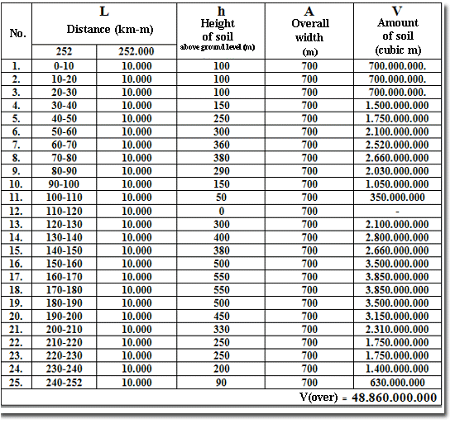
V(over) = 48.860.000.000 cubic m.
+V(canal) = 6.300.000.000 cubic m.
V (Total) = 55.160.000.000 cubic m.
or = 55,2 billion cubic m.
Such a huge amount of redundant soil (stone, gravel) inadvertently leads to the thought: "And what to do with such a huge amount?"
Following the logic of the Japanese living on the islands and permanently occupy the territory by sea, I made the calculations, ask yourself the question: "How to increase the area of the country if a large part of soil excavated during the construction of the channel, pour along the coastline of the Mediterranean?"
Results of the imagination:
Calculation
volume of seawater in the western coastal belt of Israel.

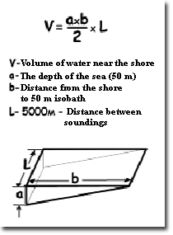

The calculation
of dumping soil on the western coastal belt of Israel.

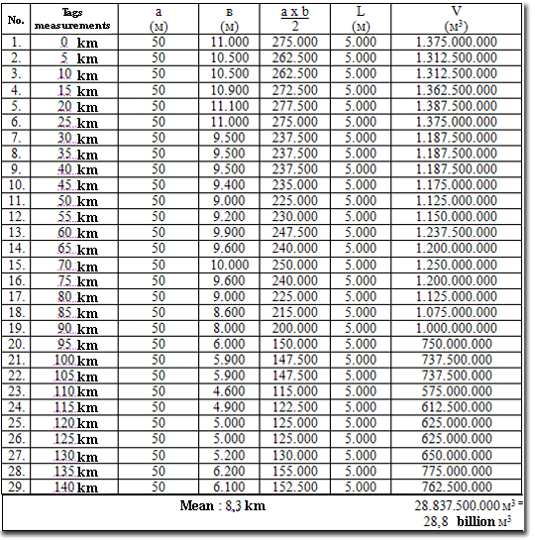

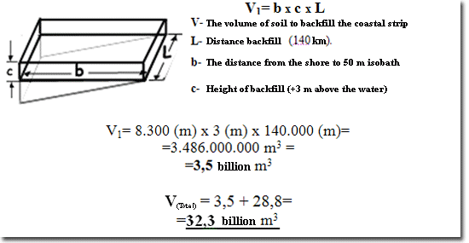

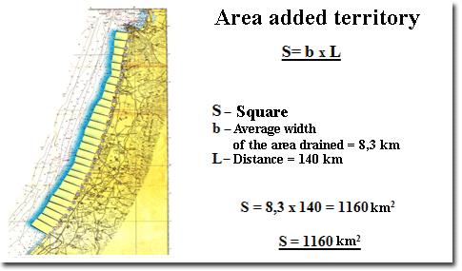

Conclusions:
1.What is the Land of Israel? - If all the hollows, and mountains of Israel to straighten it is-the whole world. (Torah)
I do not doubt the fact that, having carried out the construction of Israel's Ship Canal, Israel launched a revolution in international relations and their welfare.
In international relations, international community will have the unique option-modern canal in a civilized country, as well as participated in many joint industrial and trade relations.
In his well-being - hitherto unheard-income countries, of course, will lead Israel to the well-being for all time.

In other words: If all the hollows and mountains of Israel to straighten, ie, remove the soil from the mountain height of 600 m and 100-meter basin, converging to the Dead Sea, filled with water channel, then realized the attraction to this place around the world. Consequently, as a result of this world closer to Israel, and he will, as stated in the Torah - the whole world!

2. Why that way, if it does not lead to the Temple?

The great wisdom behind this is not a simple matter.
Since ancient times, has come to us understanding that the road is kind of cleared the construction, allowing no obstacles, the fastest to reach the target.
The road connecting the towns and the villages. And in every village and every town was connected to the importance of more qualitative way. And in the center of convergence of all the most extensive and quality of roads need is a temple.
The Christians have his, and Muslims have his.
We Jews should care about restoring our Main Temple!

Gone are the days when our temple destroyed then the Babylonians, the Romans!
The book teaches that the Temple can be built when all the Jews of the world return to the Israel, when the Messiah will come!
Today, I think, almost all the Jews here. Since those that do not set foot on the Israel, have that opportunity, spending a few hours. The development of communication and information such that they can follow up to the minute, for what is happening in the country of Israel.
As for the Messiah, then He is not nothing but a whole Jewish people, who arrived in the land of Israel, packed academic education and knowledge to the envy of all the peoples of the world. Just the source - read the Torah must be just right!

Based on all mentioned above, we continue to ask myself questions and answer them yourself:
"If the road that you have built, blue as the color of the flag of Israel, if this road all the peoples of the world have brought you a present of all that is produced,
If you, the construction of this road, made of stone, taken from
Earth (over 55-ty billion m3), you can build a temple?
Where does this road lead? "
Then this road, yes, leads to the temple!

I am sure, if you combine our knowledge, experience, and thus to understand that we - the driving force behind the people, we all get there. It is important to step by step, to find solutions and ways to overcome difficulties faced in the implementation of our project to move forward - to implement it - the road to the Temple - navigable channel, to a prosperous Israel!

The man did nothing for the construction of the Temple, is guilty of its destruction.
(The Lubavitcher Rebe)

The generation that did nothing for the construction of the Temple, there was nothing!
(The Book of Zohar)

Yuri Goldman (Dedov) – Author of the Project.
21.07.2009 – Ashkelon, Israel

www.isracanal.com

Mob.(972)-52-88-50-361

